Amazon Web Services

Simple Storage Service

Simple Storage Service – S3
- S3 is a secure, durable, and highly scalable object storage.
- S3 is easy to use, with a simple web service interface to store and retrieve any amount of data from anywhere on the web.
- This means customers of all sizes and industries can use it to store and protect any amount of data for a range of use cases, such as websites, mobile applications, backup and restore, archive, enterprise applications, and big data analytics.
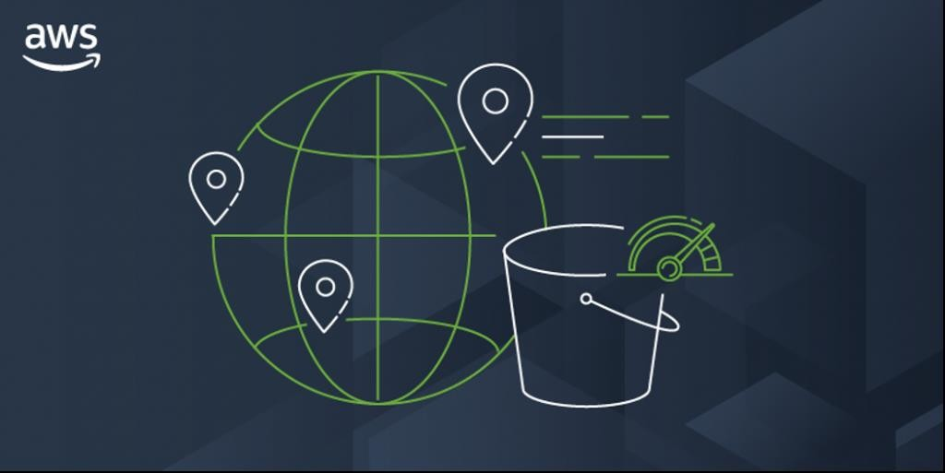

S3 - Features
- It is a global service
- Low latency and high throughput performance
- It is a Safe place to store your files
- It is object-based storage
- Durability: AWS claims Amazon S3 to have a 99.999999999% of durability. This means the possibility of losing your data stored on S3 is one in a billion.
- A single Amazon S3 object can store a maximum of 5 terabytes.
- The total volume that an s3 bucket can store is unlimited. If an object size is greater than 5 gigabytes, you should consider multipart upload.
- S3 Bucket Names must be unique globally.
- Lifecycle Management
- Versioning
- Encryption
- Secure Your data using Access Control lists & Bucket Policy

S3 - Restrictions and Limitations
- Bucket ownership is not transferable to another account.

- When we create a bucket, we choose its name and the AWS Region to create it in.

- After we create a bucket, we can't change its name or Region.

- By default, we can create up to 100 buckets in each of our AW’S accounts.

- If we need additional buckets, you can increase our account bucket limit to a maximum of 1,000 buckets by submitting a service limit increase.

- There is no difference in performance whether you use many buckets or just a few. (Note: Search Service Quotas in AWS)

S3 - Priced
- Amazon Simple Storage Service (Amazon S3) is an elastically scalable object storage service. The service provides a free tier to get you started, with limited capacity for 12 months.

- Storage Tiers: AWS S3 prices per GB-month of storage, and pricing varies according to the storage tier you select. The AWS S3 Standard tier provides instant access with low data retrieval costs, but a relatively high cost per GB. There are lower cost tiers that offer lower cost per GB, but higher cost of data retrieval or delayed data retrieval.
- Cost per requests: AWS S3 has a cost per 1,000 requests, depending on the request type.
- Data Transfer: There are extra charges for data transfer from AWS S3 to the Internet, or to certain AWS regions.
- Management and analytics: AWS S3 charges extra for automating the data lifecycle and moving data automatically to the most optimal storage tiers.
- Replication: if you set up replication in AWS S3, data transfer and operations
performed during replication are charged like regular AWS S3 operations.

S3 - Overview of Buckets
- Amazon S3 Allows people to store objects (Files) in the
“buckets” (Directories)
- Buckets must have globally unique names
- Buckets are defined at the region level
- Naming Convention
- No Uppercase
- No Underscore
- 3 – 63 Characters long
- Not an IP Address (224.245.278.135)
- Must start with a lowercase letter or number

S3 – Create Bucket
- Click on Create Bucket

- Enter the bucket name

- Select the region

- Select ACLs Enabled

- Uncheck the block all public access

- Check the acknowledge

- Click on Create bucket

S3 - Upload Object
- Click on the name of the bucket

- Click on Upload

- Click on Add files

- Select the file which we want to upload in our S3 bucket

- Click on permissions

- Select grant public read access

- Click on Upload

S3 - View Object
- Click on the name of the object

- Go to the properties tab

- Copy the object URL

- Paste in the browser

- Change permission of the object

- Click on the name of the object

- Go to Permission tab

S3 - View Object
- Click on Edit

- Uncheck read access from public access

- Click on save changes

- Paste the object URL in browser

